Pythagorean Theorem
Hind Ali

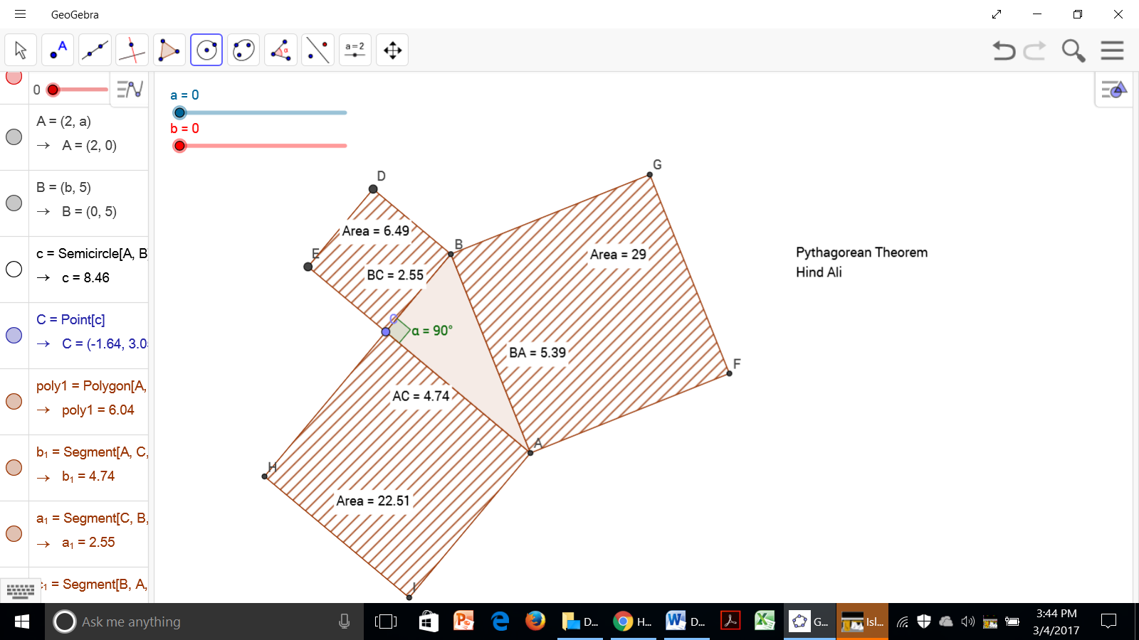

The Pythagorean Theorem is the statement that the sum of (the areas of) the two small squares equals (the area of) the big one.
Use GeoGebra to construct a right triangle and the squares of its sides to demonstrate a proof of the Pythagorean Theorem by doing the following steps:
- Start by making a segment.
- Construct a semicircle from the segment end points.
- Plot a point on a semicircle (use point on object).
- Hide the semicircle.
- Construct a triangle by segmenting all points.
- Measure the right angle with the angel tool.
- Measure the length of each triangle side by using the distance tool, clicking once in each triangle side.
- Move the measure by dragging it in a convenient location with the move tool.
- Turn the triangle sides into squares by using the regular polygon tools.
- Measures the area of each square by using the area tool and clicking once on each square.
- Move the measure by dragging it in a convenient location with the move tool.
- Add slider to your graph.
- Name your construction by using the insert text tools.
- Add your name to the construction.

